# 

## Overview

Next week we dive into learning HTML and CSS. We need to make sure we have the right tools for the job. In this activity, you’ll take some time to install the necessary software.

*Note:* You may have already installed these tools as part of your pre-boot camp preparation. If that’s the case, use this time to further familiarize yourself with the tools.

## Instructions

**Part 1: Install Visual Studio Code (or VS Code)**

1. Visual Studio Code is the recommended text editor for this class, and it will be used for examples and assignments throughout the boot camp.
   * *Note: There are other text editors out there, and you are encouraged to explore other options. However, using the same editor as your instructor might make it easier to follow along while coding.*
2. Download Visual Studio Code [here](https://code.visualstudio.com/download) and select the right version for your operating system.

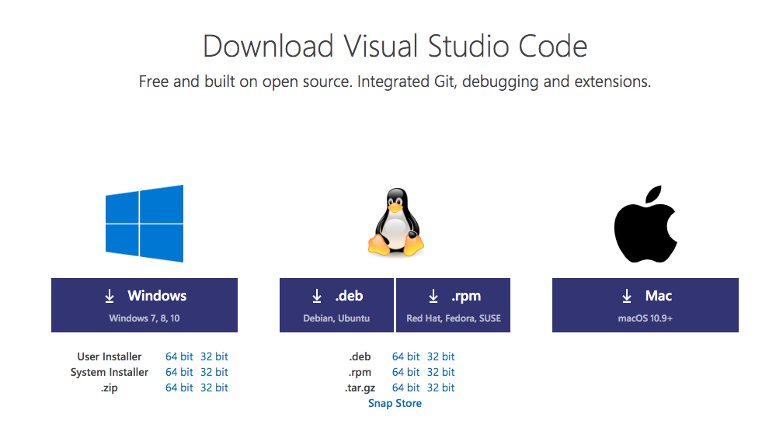

**Part 2: Create a GitHub Account**

1. Go to [GitHub.com](https://github.com) and create an account if you do not have one.

**Part 3: Install GitHub Desktop**

1. As discussed in the course prework, GitHub Desktop is a graphical user interface for Git. This tool will be used to manage your code and projects on GitHub.
2. Download GitHub Desktop [here](https://desktop.github.com/).

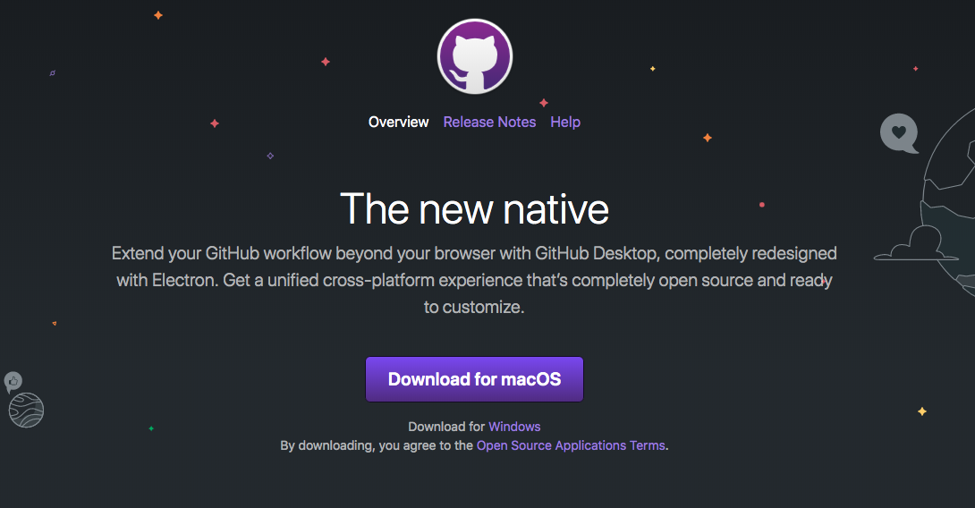

1. Open both Visual Studio Code and GitHub Desktop.

**Part 4: Create a CodePen Account**

1. Go to [Codepen.io](https://codepen.io/accounts/signup/user/free) and create an account.

**Part 5: Create a Local Folder to Store Your Code**

Set up a local folder to store all the code you will be working on during boot camp. This will help you stay organized and will allow you to refer back to concepts as you execute on homework.

1. Create a new folder called **MyCode.**
   1. Save the folder in your **Documents** folder.
2. Create four subfolders:
   1. 16-Week
   2. 17-Week
   3. 18-Week
   4. 19-Week

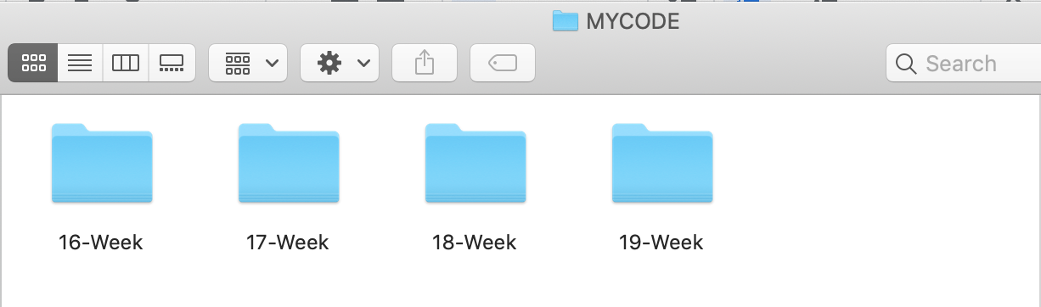

**A Word on Text Editors**

We’re using Visual Studio Code as our text editor. There are others to choose from. Text editors are provided with [operating systems](https://en.wikipedia.org/wiki/Operating_system) and software development packages and are very useful for creating and editing folders and files like HTML, CSS, and JavaScript files.

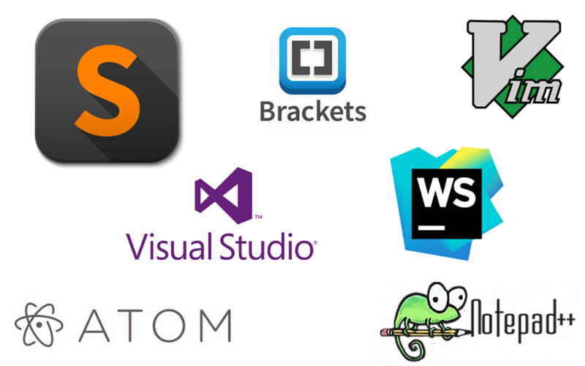

**In the Real World**

Design and development tools change constantly. Typically, the tools designers use and tools developers use have not overlapped all that much, but as we learn front-end development, we will familiarize ourselves with how to use some developer tools and relate our tools to one another.